**Aim:** To Study Agile Methodology and Test case Management using JIRA Tool

**Theory:**

Jira is a software development tool that helps team’s plan, track, and release software projects. It's a popular tool among software development teams. JIRA is a widely used issue tracking and project management software developed by Atlassian.

The theory behind JIRA revolves around several key principles and concepts:

* Issue Tracking: At its core, JIRA is designed to help teams track tasks, bugs, features, and other issues within a project. It provides a centralised platform for capturing, organising, and prioritising these items. Agile Methodologies: JIRA supports agile methodologies such as Scrum and Kanban, enabling teams to plan, track, and deliver work in iterative cycles. Agile principles emphasise collaboration, adaptability, and delivering value to customers.
* Workflow Management: JIRA allows teams to define custom workflows that represent the lifecycle of an issue from creation to completion. Workflows can include various statuses, transitions, and conditions to reflect the specific processes followed by the team.
* Customization: One of the key strengths of JIRA is its flexibility and customization options. Teams can tailor JIRA to their specific needs by creating custom issue types, fields, workflows, and project configurations. Collaboration and Communication: JIRA facilitates collaboration among team members by providing features such as commenting, mentioning, and attaching files to issues. It also integrates with other Atlassian products like Confluence and Bit bucket for seamless communication and knowledge sharing. Reporting and Analytics: JIRA offers robust reporting and analytics capabilities, allowing teams to gain insights into their project progress, team performance, and other key metrics. Users can create custom dashboards, charts, and reports to monitor and analyse project data.
* Integration: JIRA integrates with a wide range of third-party tools and services, including development tools, CI/CD pipelines, customer support systems, and more. This integration ecosystem enables teams to streamline their workflows and improve productivity.
* Scalability and Performance: JIRA is designed to scale with the needs of growing teams and organisations. It can handle large volumes of data and users while maintaining performance and reliability.

**Steps:**

# Open Atlassian.com, Select JIRA, and Login with the Required Credentials:

* + **Purpose**: Atlassian provides cloud-based software products, with JIRA being one of its most popular tools for project management and issue tracking.

# Steps:

* + - Navigate to [Atlassian's official website](https://www.atlassian.com/).
    - From the homepage, find and select **JIRA Software**.
    - You’ll be directed to the JIRA login page where you’ll need to enter your credentials

(username and password) that were provided when your JIRA account was created.

* + - If you don’t have an account, you can register for one.

# Add Yourself to a Particular Team:

* + **Purpose**: In a collaborative environment, teams are usually set up in JIRA to organize users who are working on related projects or tasks.

# Steps:

* + - After logging in, navigate to the **"People"** or **"Teams"** section of JIRA.
    - Search for the team you need to join (this will typically be an existing team assigned to a project or area of work).
    - Click to **request membership** or add yourself to the team, depending on the settings in your organization.
    - Your project manager or administrator might approve your membership.

# Complete the Tasks Given by Your Project Manager:

* + **Purpose**: JIRA is often used to assign and track tasks within a project. Your project manager will create tasks or issues within JIRA and assign them to you.

# Steps:

* + - Once added to the team and assigned tasks, head to the **"Dashboard"** or **"Active Sprint"** section, where your tasks or issues are listed.
    - Each task is typically represented as an issue (which can be a bug, feature, improvement, etc.).
    - Open the assigned task, review the details, and start working on it.
    - Update the status of the task as you progress, marking it as **In Progress**, **Under Review**, or **Done** based on your progress.

# Create Projects and Assign Them to Your Team Members:

* + **Purpose**: As a team member or project manager, you might have the ability to create new projects and manage teams or assign tasks within those projects.

# Steps:

* + - Navigate to the **"Projects"** section and select **"Create Project"**.
    - Define the project name, description, and type (Scrum, Kanban, etc.).
    - Once the project is created, you can start adding tasks (issues) and assign them to different team members, giving them due dates and priority levels.
    - You may also configure workflows for different project phases.

# Create Your Own Test Cases:

* + **Purpose**: In software development or other industries, creating test cases is essential for quality assurance. JIRA allows you to document these test cases to track and ensure quality.

# Steps:

* + - Go to your JIRA board and create a new **"Issue"** (often labeled as a “Test Case” in

specific testing workflows).

* + - Add the details of the test case, such as **Test Description**, **Test Steps**, **Expected Results**, and **Actual Results** once executed.
    - Assign the test case to yourself or another team member for execution.
    - The test case can be linked to specific tasks or user stories to ensure quality checks are included in the process.
    - Update the status of the test case after completion, whether it passes or fails.

This process helps manage tasks and projects efficiently in JIRA, ensuring transparency and accountability within a team or project.

**Output:**

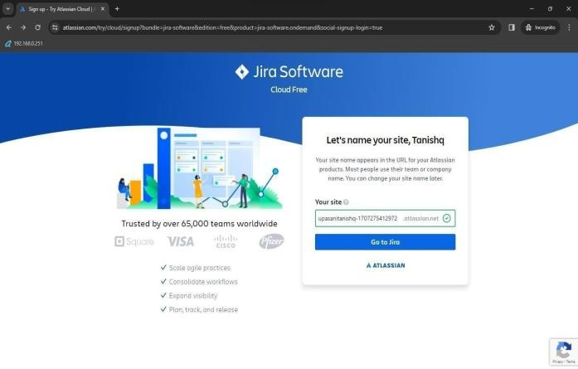

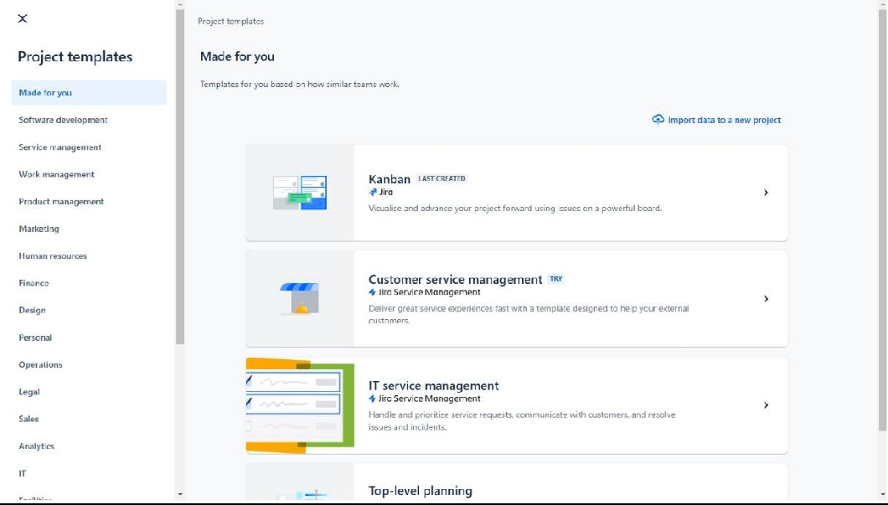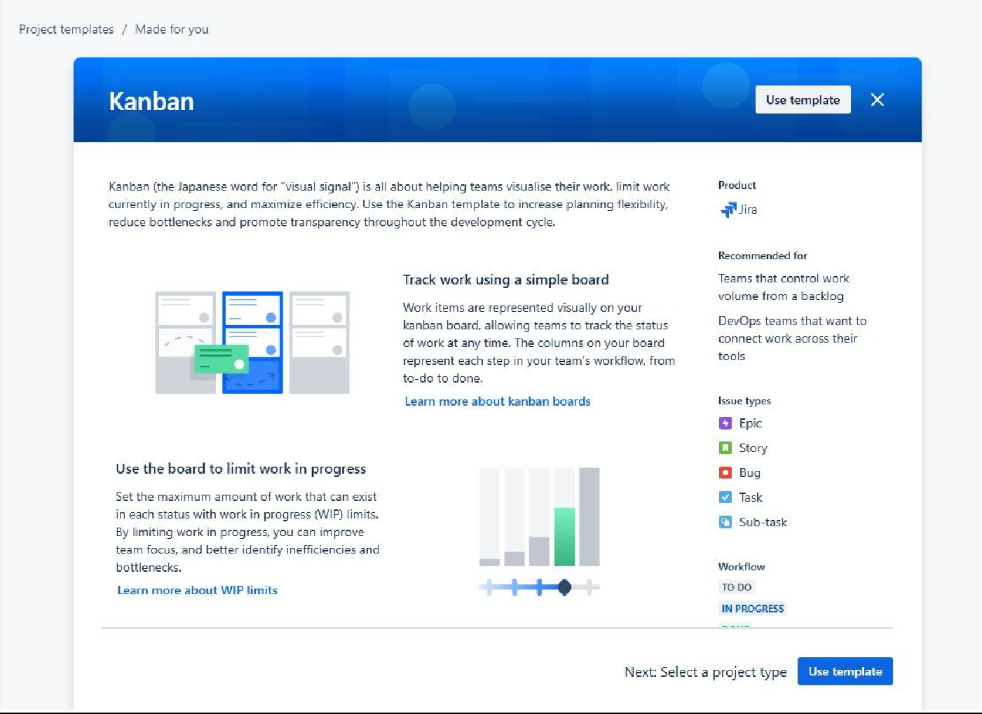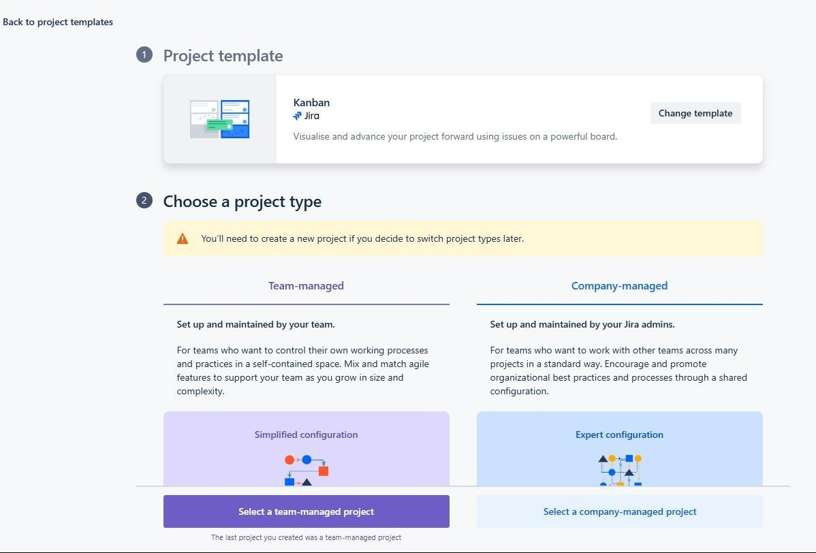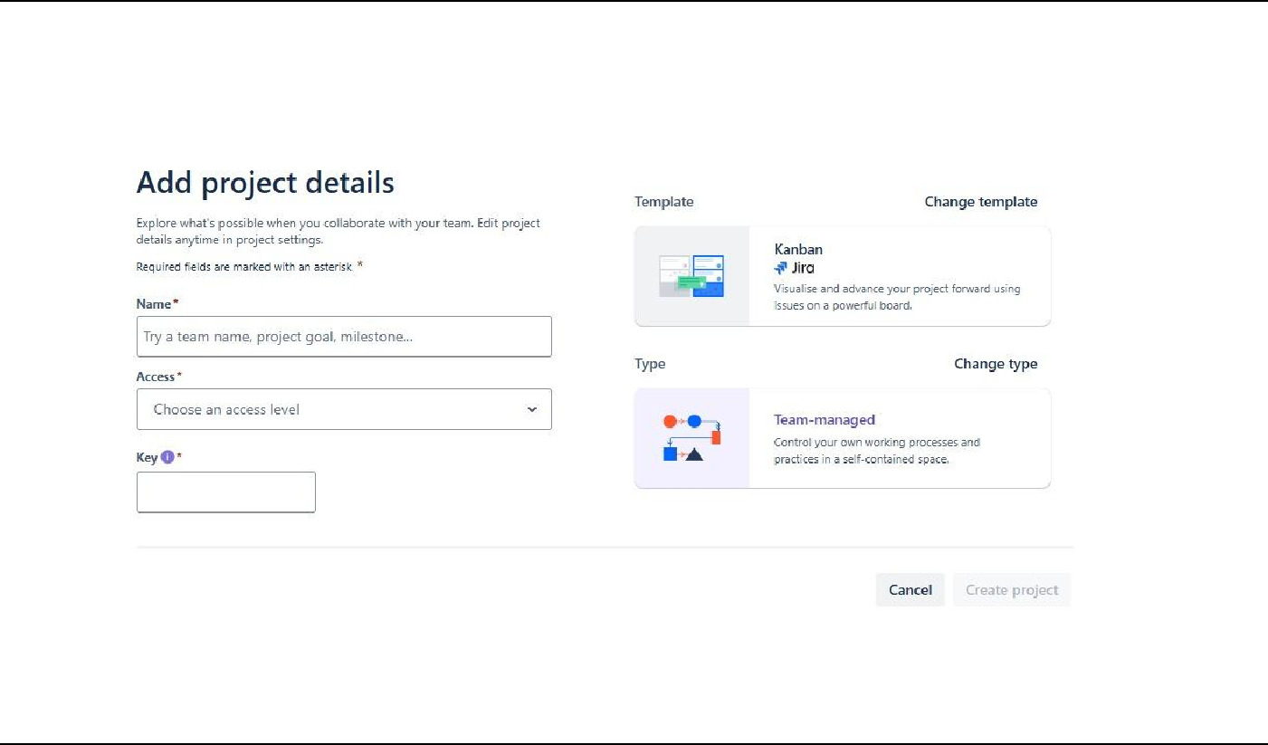

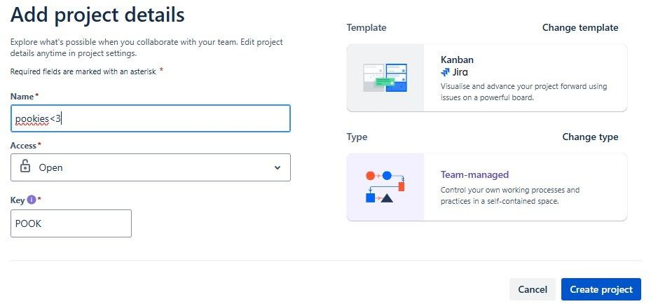

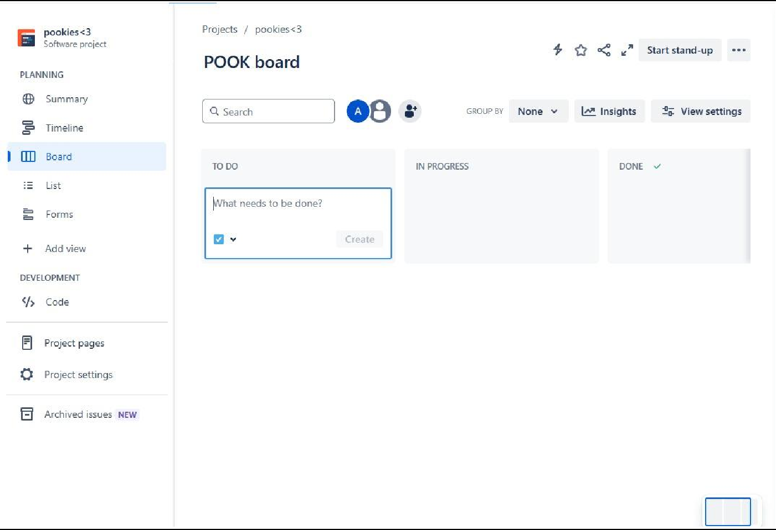

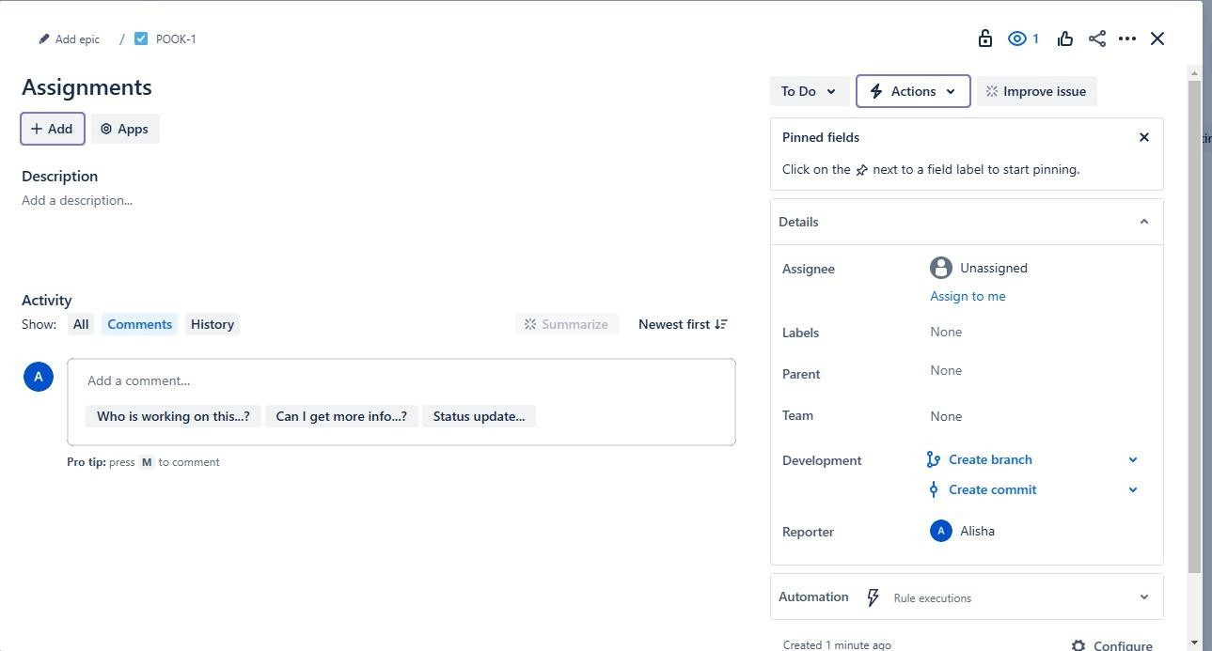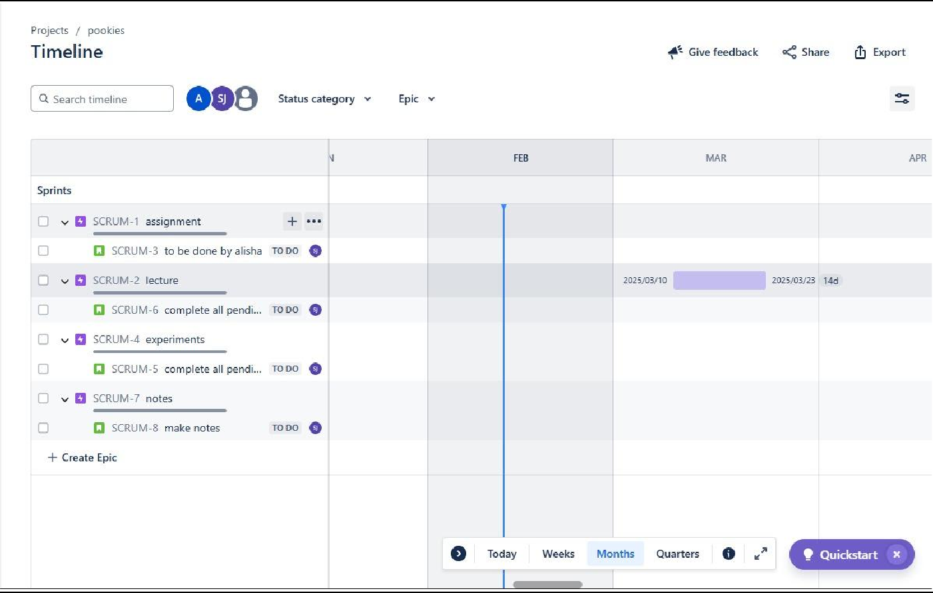

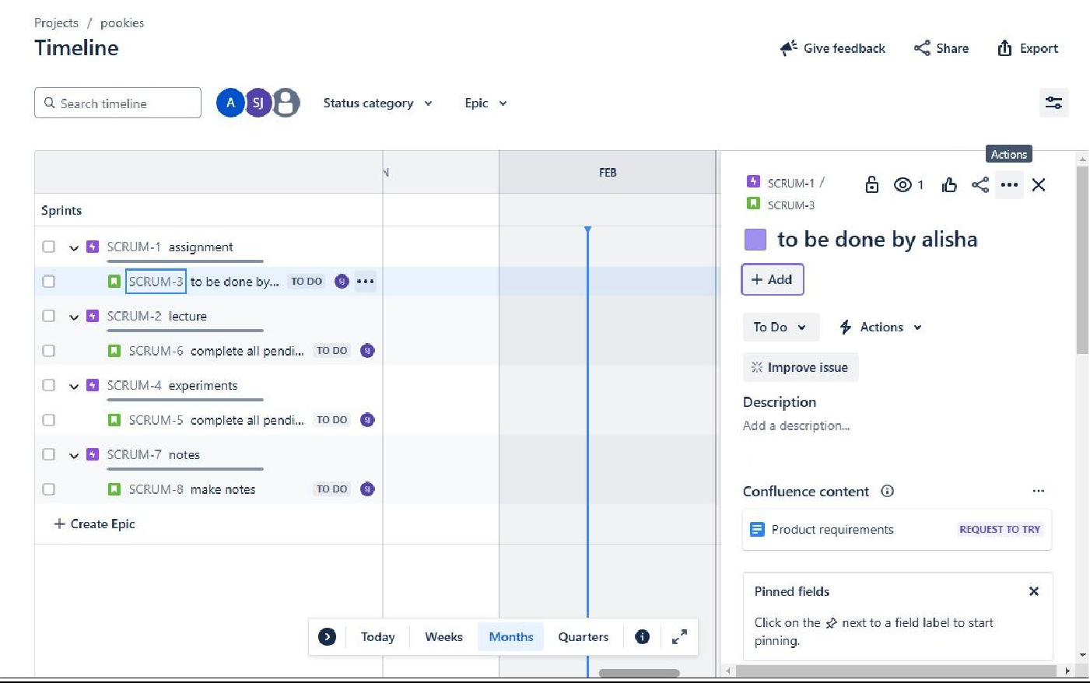

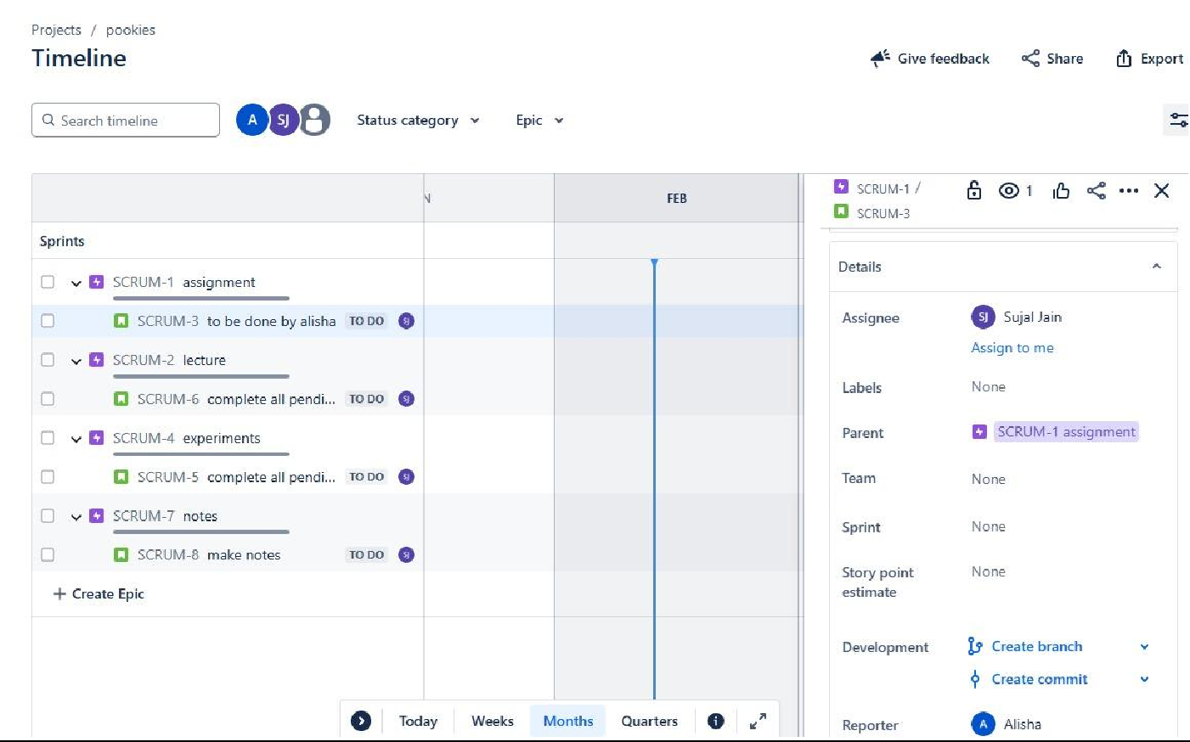

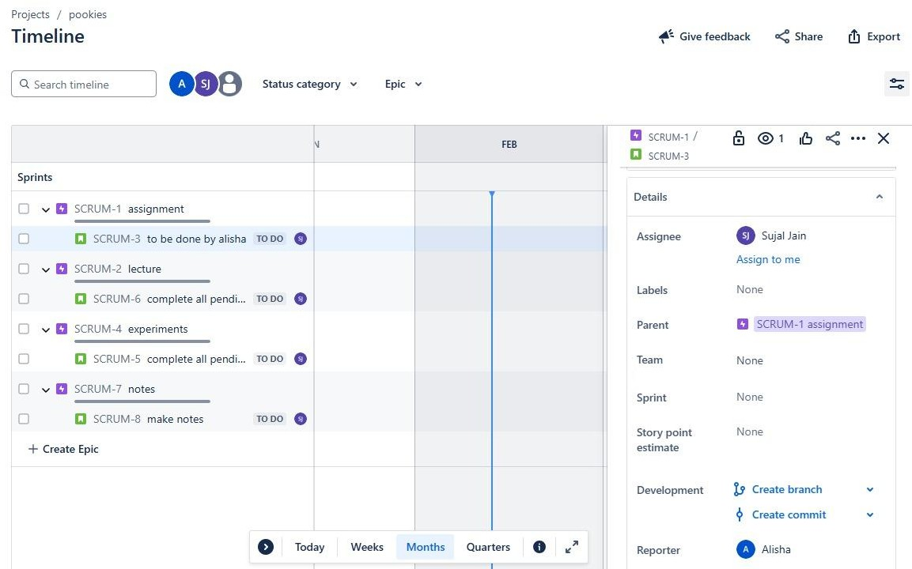

**Conclusion:** Thus, we have successfully implemented Agile Methodologies in JIRA.

**LO Mapping:** *LO3 is mapped.*